**Custom Hashing Algorithm**

This is a simple hashing algorithm which provides a random hash value for a given input

**Features:**

* It takes data in string format and gives hash output
* It can also read input from text files from a given file path

**Working:**

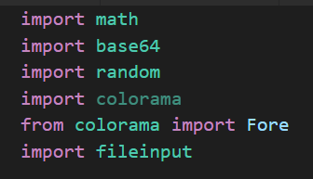

These are the libraries imported and used in the code…

User input:

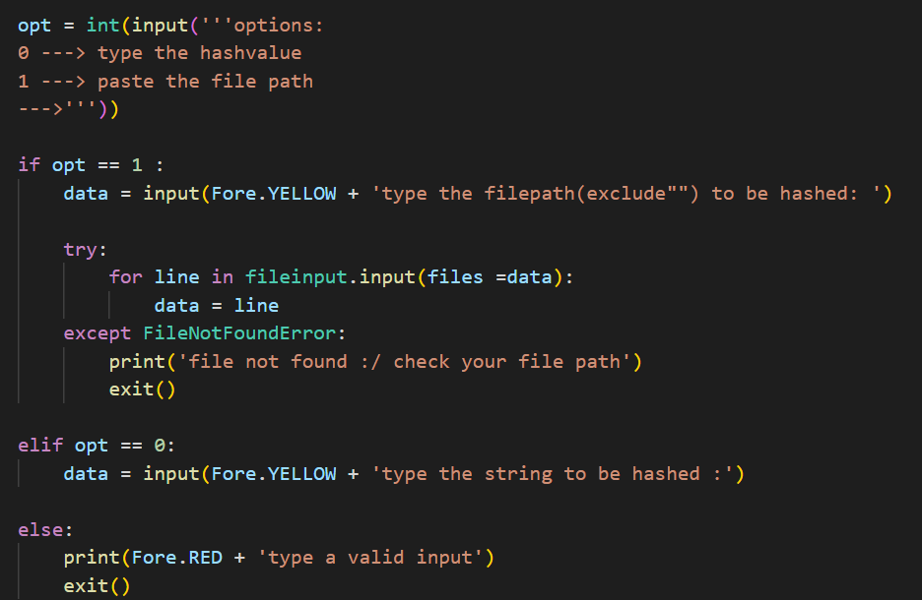

The string is rotated and base64 encoded:

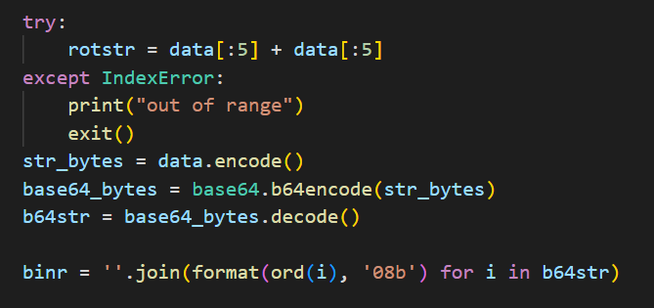

Padding is done to fix the bit length to N*128 bits:

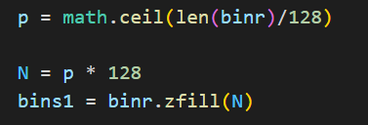

Random bits in the data are replaced with 1s using the random function with a fixed seed:

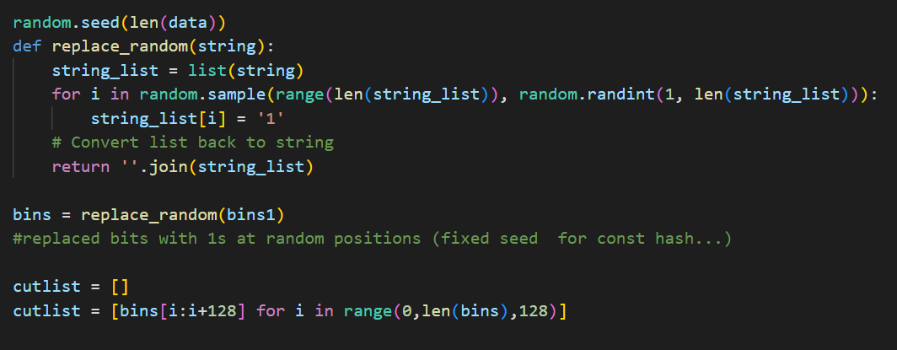

Bitwise operations are performed on the data:

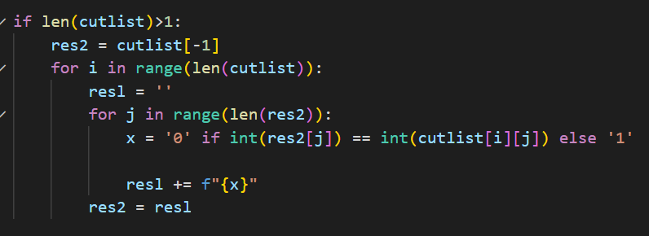

Finally, the output is converted into hex and printed:

